|  |  |
| --- | --- |
| **Style No.** PBLT03 Phoebe Small Ceiling Mounted LED Flush Mount with Glass Diffuser | **Style No.** PBLT04 Phoebe Large Ceiling Mounted LED Flush Mount with Glass Diffuser |
|  |  |

**SPECIFICATIONS:**

Bulb Base Size: LED

Bulb Type: LED BOARD

Junction Box Orientation: Any

Junction Box Size: Standard 4: Octagon

Max Wattage: 12 Watt

Orientation: Ceiling, or Wall

Diffuser Material: Glass

Voltage: 120

Required Electrical Feeds:

US: Black “Hot” wire; White “Neutral” wire; Green or Bare

“Ground” wire

**IMPORTANT:**

* WARNING: The power supply must be turned off prior to installation. Turn off the main electrical supply to the junction box from the fuse box/circuit breaker. Turning power off at the switch is not sufficient.
* To ensure this product is installed properly, you must read and follow these guidelines.
* The owner/user of this product must keep this information for future reference.
* PBLT03/PBLT04 are U.L. certified and are suitable for damp or dry locations. The U.L. listing mark can be found on the inside of the cover plate.
* Be sure your installation conforms to all federal, state, and local codes.
* This product must be installed by a professional licensed electrical contractor.
* Refer to the specification and assembly drawings attached. Product is sold partially assembled but shown fully disassembled for illustrative and service purpose only.

**PBLT03 / PBLT04 FLUSH MOUNT INSTALLATION:**

* REQUIRED: Install a Gem Box electrical junction box at the desired location.
* See Figure - 01 for Steps 1 - 5.

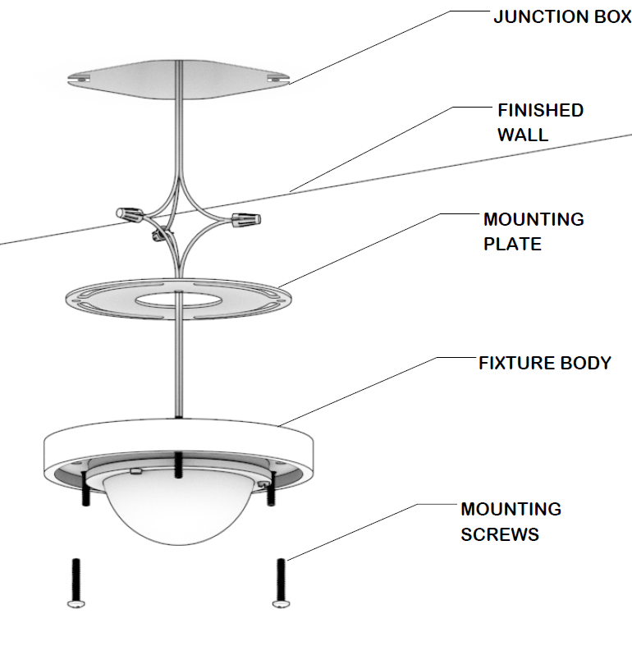

FIGURE – 01

1. Pull the wires from junction box
2. Fasten the bare copper fixture wire to the green or bare copper wire in the box with a wire nut or fasten it to the MOUNTING PLATE with the ground screw provided.
3. Fasten the white fixture wire to the white wire in the box with a wire nut. Tightly wrap the connection with electrical tape beginning 1” [25mm] below the wire nut to ensure the tape seals the end of the nut. Make sure that there are no exposed wires that could cause a short circuit.
4. Repeat previous step with the black fixture wire and the black wire from the junction box. Make sure the wires are pushed into the junction box.
5. Attach the MOUNTING PLATE to the FIXTURE BODY, and JUNCTION BOX using the MOUNTING SCREWS making sure to keep the proper alignment of the plate.

* See Figure - 02 for Step 6.

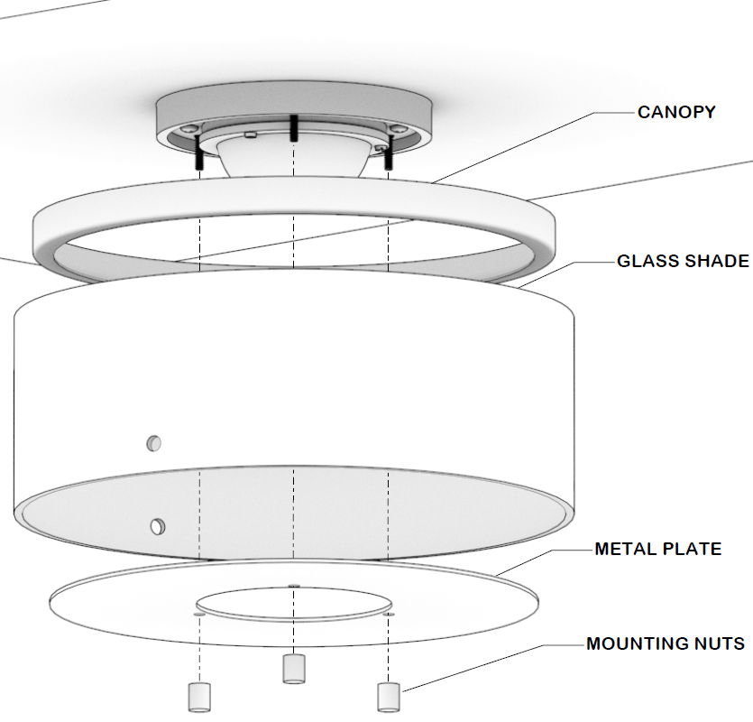

FIGURE – 02

1. Use the METAL PLATE, and MOUNTING NUTS to secure the CANOPY, and GLASS SHADE to the ceiling.

* See Figure - 03 for Step 7.

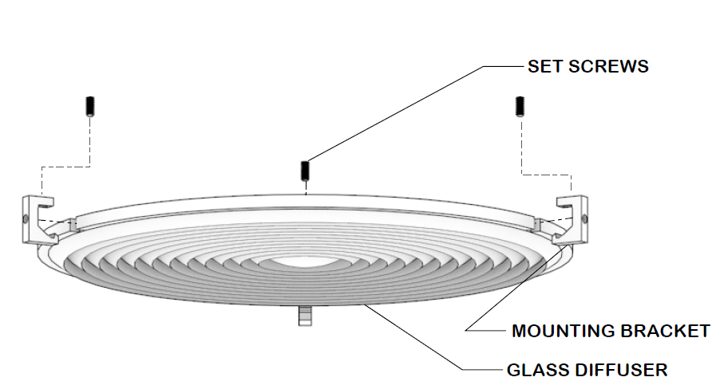

1. Assemble the GLASS DIFFUSER by moving the MOUNTING BRACKETS into the notches of the GLASS DIFFUSER, and secure MOUNTING BRACKETS with SET SCREWS

* See Figure - 04 for Step 8.

1. Use the SET SCREWS to secure the GLASS DIFFUSER with the MOUNTING BRACKETS to the GLASS SHADE.

**SERVICING THE LIGHT:**

1. Unscrew the SET SCREWS to gain access to the LIGHTBULB for cleaning and servicing.

* If further assistance is required, please contact Product Support at 1-800-927-2120 (8am-6pm EST).